<page_start no = 1>
<sol_start id=1>
1. LCM (36, 45) = 2² × 3² × 5 = 180 Sec = 3 min
36 = 2² × 3²
45 = 3² × 5
Ans. :
<sol_end>

<sol_start id=2>
2.
=
=
=
=
Ans. :
<sol_end>

<sol_start id=3>
3. 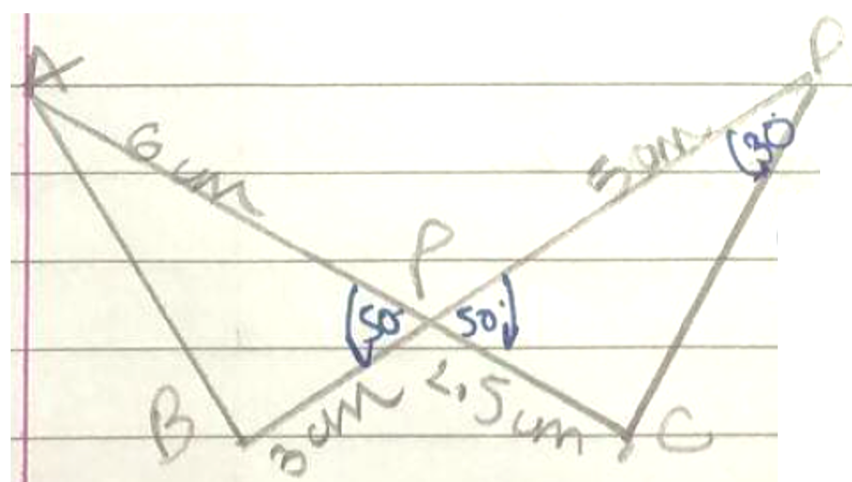
(vertically opposite angles)
By SAS similarity
= 180 – 80 = 100°
Ans. :
<sol_end>
<page_end>

<page_start no = 2>
<sol_start id=4>
4. ~
PR² = 100
PR = 10 un
Ans. :
<sol_end>

<sol_start id=5>
5. P(x) = x² + (a+1) x + b
P(2) = (2)² + (a+1)² + b
0 = 4 + 2a + 2 + b
0 = 6 + 2a + b
(–6) = 2a + b …..(1)
P(–3) = (–3)² + (a + 1) (–3) + b
0 = 9 – 3a – 3 + b
–6 = b– 3a …(2)
Equating equation 1 and equation 2
Ans. :
<sol_end>
<page_end>
<page_start no = 3>
<sol_start id=6>
6.
Denominator = 2^{m} × 5^{n}
2¹×5^{n} = 2m × 5n
m = 1
n = 4 m < n
the no. will terminate after 4 decimal places
Ans. :
<sol_end>

<sol_start id=7>
7. x = a
y = b
x – y = 2
a – b = 2 …..(1)
x + y = 4
a + b = 4 ….(2)
add equation 1 and equation 2
2a = 6
a = 3
Put a in equation 1
3 – 2 = b
1 = 6
Ans. :
<sol_end>
<page_end>

<page_start no = 4>
<sol_start id=8>
8. 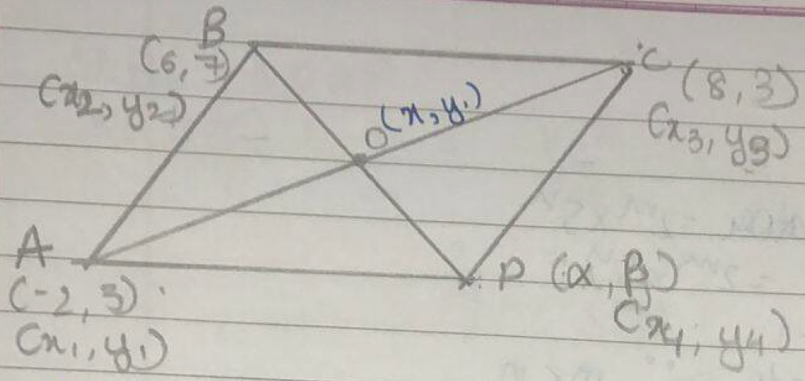
Join AC and BD and intersect at 0.
diagonals bisect each other in a 11^{gm}
0 is mid point of both the diagonals
y =
Ans. :
<sol_end>
<page_end>
<page_start no = 5>
<sol_start id=9>
9. 9x + 3y + 12 = 0
18x + 6y + 26 = 0
Ans. :
<sol_end>

<sol_start id=10>
10. 2x – 3y + 10 =0
3x + ky + 15 =0
As coincident lines
Ans. :
<sol_end>

<sol_start id=11>
11. 10x – 5 y + 15 = 0
6x + ky + 19 = 0
As intersecting lines
Ans. :
<sol_end>
<page_end>
<page_start no = 6>
<sol_start id=12>
12. HCF (6, 6, 32) = 2³ = 8
616 = 2³ × 7 × 11
32 = 2⁵
8 rows
Ans. :
<sol_end>
<sol_start id=13>
13.
<sol_end>

<sol_start id=14>
14. a = x³ y⁴ z²
b = x² y z⁴
LCM (a, b) = x³ y⁴ z⁴
Ans. :
<sol_end>

<sol_start id=15>
15. = (–3)
= (4)
+ = –3 + 4 = 1
= (–3)4 = (–12)
k[x² – x(+) + ]
k[x² – x –12]
Ans. :
<sol_end>

<sol_start id=16>
16.
<sol_end>
<page_end>

<page_start no = 7>
<sol_start id=17>
17.
<sol_end>
<sol_start id=18>
18. Let ~
Ans.
<sol_end>

<sol_start id=19>
19. A : x² – 4x – 5
x² – 5x + x–5 = 0
x(x – 5) + (x – 5) = 0
(x + 1) (x – 5) = 0
x = 5; (–1)
R :
P(x) = x² –4x + 1
Ans.
<sol_end>
<page_end>
<page_start no = 8>
<sol_start id=20>
20. 3(k–1)x + 4y –24 = 0
15x + 20y –8(k+13) = 0
k –1=1
k = 2
Ans.
<sol_end>
<page_end>
<page_start no = 9>
<sol_start id=21>
21. To prove :
6 × 5 × 4 × 3 × 2 × 1 + 5 is a composite no.
725 = 5 × 5 × 29 × 1
It has more than two factors the number is composite number
Hence proved
<sol_end>

<sol_start id=22>
22. 4x + 6y = 7 4x + 6y –7 = 0
kx + 18y = 21 kx + 18y – 21 = 0
a₁ = 4 b₁ = 6 c₁ = (–7)
a₂ = k b₂ = 18 c₂ = (–21)
As a system of linear equation of infinite solutions.
k = 12
<sol_end>
<page_end>
<page_start no = 10>
<sol_start id=23>
23. Let distance between origin and (–6, 8) be AB
x₁ = 0 y₁ = 0
x₂ = (–6) y₂ = 8
Applying distance formula
AB = 10 u
Ans.
<sol_end>

<sol_start id=24>
24. sin 3A = cos(A–10)
sin A = cos(90–A)
so sin 3A = cos (90–3A)
cos(90–3A) = cos (A–10)
on comparing angles.
90–3A = A–10
100 = 4A
Ans.
A is equal to 25.
<sol_end>
<page_end>
<page_start no = 11>
<sol_start id=25>
25. 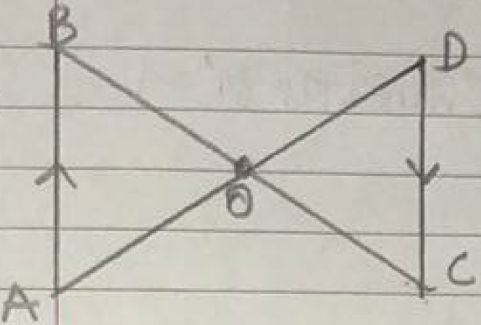
given AB||CD.
to prove
proof AB||CD
[alternate interior angles)
[alternate interior angles)
By AA similarity criterion
Hence proved.
<sol_end>
<page_end>
<page_start no = 12>
<sol_start id=26>
26. To prove :
+tan1°·tan10°·tan80°·tan89° = 1
proof
tan1° = cos(90–1°)
= cot89°
tan10° = cot(90–10°)
= cot80°
+tan1°·tan10°·tan80°·tan89°
+ cot89·tan89·cot80°·tan80
0+(1) (1)
0 + 1
1.
Hence proved.
<sol_end>
<page_end>

<page_start no = 13>
<sol_start id=27>
27. Basic proportionality theorem states that. If a line is drawn parallel to one side of triangle intersecting the other two sides in distinct points then other two sides are divided in same ratio.
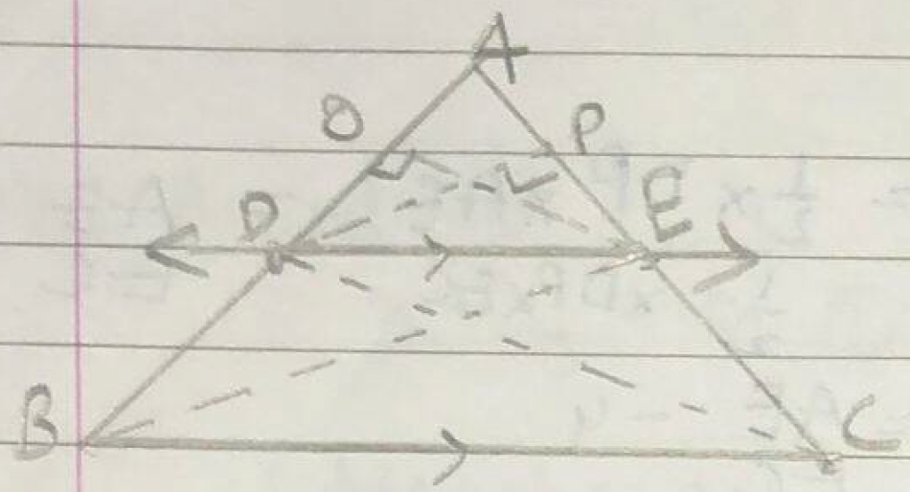
given ED||BC
to prove
construct (1) Join BE and CD.
(2) then draw a perpendicular EO such that .
(3) draw a perpendicular .
area of …..(1)
area of …..(2)
dividing equation 1 by equation 2
…..(3)
similarly :
…..(4)
area = area …..(5)
[they lie on same base DE and between 11e lines)
from equation 4 and 5.
…..(6)
from equation 3 and equation 6.
Hence proved.
<sol_end>
<page_end>
<page_start no = 14>
<sol_start id=28>
28. Let
fixed charge be ‘x’ rupees
extra charge be ‘y’ rupees
(per day)
Case-I : Latika paid ₹22
x + 4y = 22 …..(1)
Case-II : Anand paid ₹16
x+ 2y = 16 …..(2)
subtract equation 2 from equation 1.
x + 4y – [x+2y] = 22–16.
2y = 6
y = ₹3
substitute y = 3 in equation 1
x + 4(3) = 22
x = 22 – 12
x = 10
fixed charges is ₹10/- and extra charge per day is ₹3/-
<sol_end>
<page_end>
<page_start no = 15>
<sol_start id=29>
29. Area of quadrilateral ABCD = area of + area of
= 72 u²
area of quadrilateral is .
<sol_end>

<sol_start id=30>
30. HCF (1353, 861) =
1353 = 861 × 1 + 492
861 = 492 × 1 + 369
492 = 639 × 1 + 123
369 = 123 × 3 + 0
HCF of 1352 and 861 is
<sol_end>
<page_end>

<page_start no = 16>
<sol_start id=31>
31. 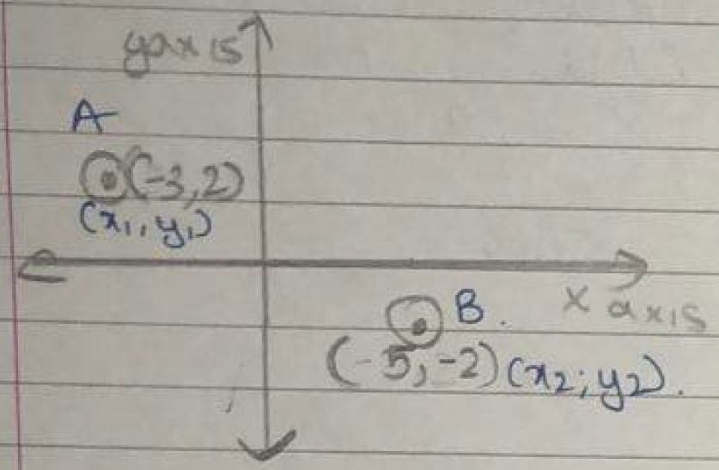
A = (–3, 2)
B = (5, –2)
D = (x, 0)
x₁ = (–3) y₁ = 2
x₂ = 5 y₂ = (–2)
AD = BD
Applying distance formula
Squaring on both the sides
(x₁–x₃)² + (y₁–y₃)² = (x₂×x₃)2 + (y₂–y₃)²
(–3–x)² + (2–(0))² = (5+(+2))² + (–2)²
x² – 6x = 40
x²–6x–40 = 0
x²–10x+4x–40 = 0
x(x–10)+4(x–10) = 0
(x–10) (x+4) = 0
x–10 = 0 x + 4 = 0
x = 10 x = (–4)
points on x axis are and .
<sol_end>
<page_end>

<page_start no = 17>
<sol_start id=32>
32.
1+secθ cosecθ
Hence proved
<sol_end>

<sol_start id=33>
33. x–y+1 = 0
If x =2 if x = 0 if x =1
2–y + 1 = 0 0 – y + 1 = 0 1 – y + 1 = 0
3 = y 1 = y 2 = y
x–y+1=0
x
0
1
2
3
2
1
y
3x+2y–12=0
x
0
2
4
0
3
6
y
if x = 2 3x+2–12=0 If x = 4
12–+2y = 0
y =0
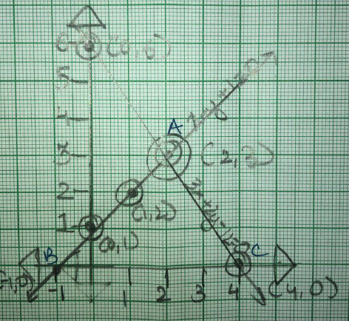

Virti us of
A – (2, 3)
B – (–1, 0)
C – (4, 0)
x₁ = 2 y₁ = 3
x₂ = (–1) y₂ = 0
x₃ = 4 y₃ = 0
area of
area of
<sol_end>
<page_end>

<page_start no = 18>
<sol_start id=34>
34.
x²–2
2x – 1
2x³–4x–x²+2
2x³–4x
–
+
0–x²+2
–x²+2
+
–
0
so 2x–1 = 0

all zeroes of polynomial 2x³–4x–x²+2 are and .
<sol_end>
<sol_start id=35>
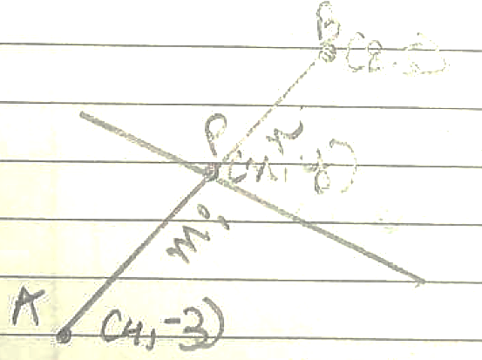
35. m : n = 3 : 1
m = 3x
n = x

x₁ = 4 x₂ = 8
y₁ = (–3) y₂ = 5
x = y =
Coordinates of point P is
<sol_end>

<sol_start id=36>
36. (i) B (0, 12)
Ans. (2) (0, 12)

(ii) P (3, 5)
Ans. (1) (3, 5)

(iii) Q (6, 9)
P (3, 5)
x₁ = 3 y₁ = 5
x₂ = 6 y₂ = 9
Applying distance formula
(3) 5 m
<sol_end>
<page_end>

<page_start no = 19>
<sol_start id=37>
37. (i)
(ii)
(iii) (–3, 2)
Ans.
<sol_end>

<sol_start id=38>
38. Area of kite =
=
(ii)
(iii) 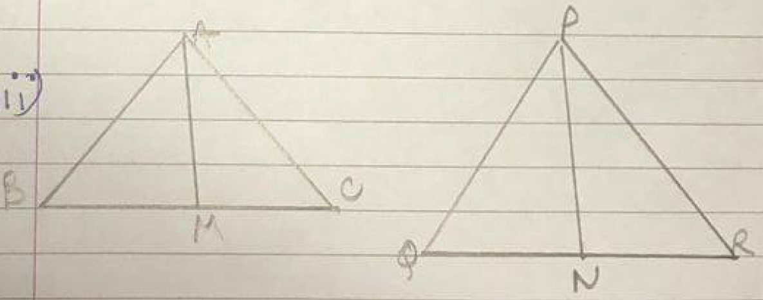
2 : 3 = AM : PN
Ans.
<sol_end>
<page_end>

